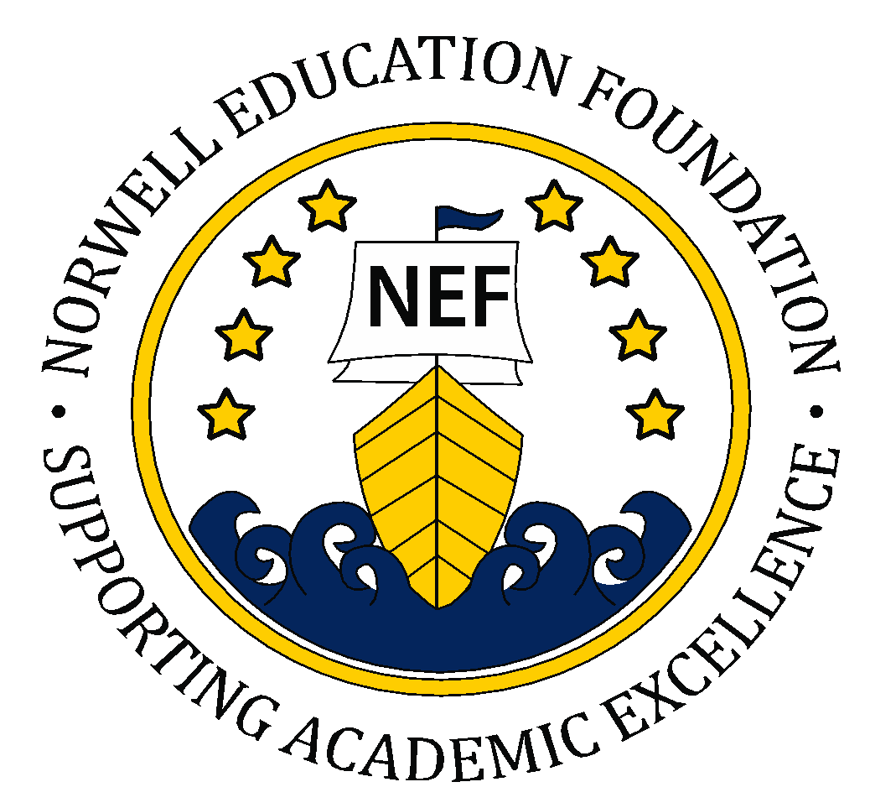
Norwell Education Foundation
PO Box 711 • Norwell, MA 02061
www.norwelledfound.org • info@norwelledfound.org

Part I. Applicant and Project Information
Project Title
Applicant Name
School
Grade/Subject
Phone
E-Mail Address

Please circle one: Individual Grant Collaborative Grant

Additional Applicants (if Collaborative Grant):
Name |  | Name
School |  | School
Telephone |  | Telephone
Email |  | Email

Number of Students Involved: ____________________ Project Beginning/Ending Dates: ____________________

Amount Requested: ____________________

As school principal, I acknowledge submission of this application and will support the applicant(s) in implementing the proposed project, if funded.

______________________________________ ________________
Signature of school principal Date

Application Due: May 1, 2020

Part II. Grant Proposal

Please provide a brief summary of your project, it’s objectives and how it will benefit you students.

Describe how you will measure the success of the project.

Part III. Budget

Provide a detailed budget and the total amount needed to fund the proposed project. Include the specific costs of all supplies, equipment and personnel.

Part IV. Agreement and Signature

By accepting funding, I agree to the following terms:
- Participate in the NEF grant evaluation process.
- Seek approval from the NEF of changes in the implementation or budget of the project.
- Publicize the project directly to parents, teachers and the Norwell community by means of the school newsletter, social media, presentations, etc. All public written communication will include the following statement: “This project is supported by a grant from the Norwell Education Foundation.”
- Encourage the replication of NEF grants by making all equipment and materials accessible to other teachers and administrators.

Name (printed)
Signature
Date

If you plan to electronically submit your grant, please e-mail your application to info@norwelledfound.org or share as a Google Doc with aabertoni@gmail.com. You will receive a confirmation of receipt within 10 days.
If you plan to submit in paper, please mail your application to: NEF, PO Box 711, Norwell, MA 02061.

